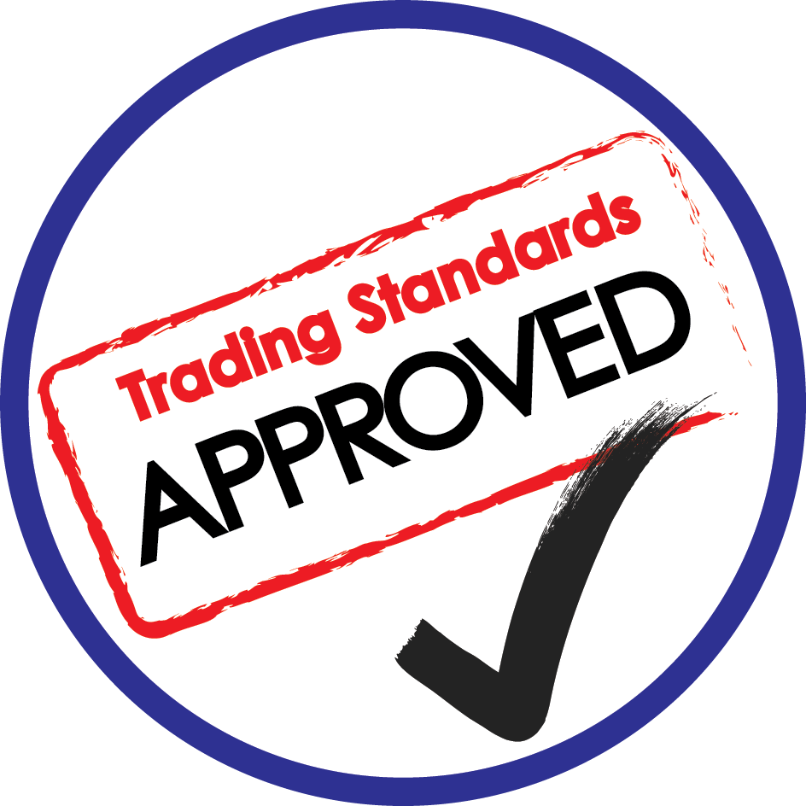
GARAGE SCHEME

1 | Introduction
The aim of the Scheme is to encourage and promote the highest standards of fair, open and honest practices, thereby giving confidence to consumers and enhancing the business reputation of its members.

The Scheme is an initiative of the City of York Council’s Public Protection Service.

2 | Eligibility
The Scheme is open to vehicle sales and vehicle repair and servicing businesses that are located within the County of North Yorkshire (including the City of York) area which trade primarily with consumers.

Applicants will be required to prove they have been trading for a period of 6 months prior to application. Previous trading need not be in the North Yorkshire area as references will be sought from independent external sources.

3 | Application for Membership
The Scheme will be administered by Trading Standards Officers within the Regulatory Support and Advice Service Team (The Administrator)

Applicants will be granted membership subject to the following:

- Receipt of a signed and dated Application Form (Appendix A)
- Payment of a Non-refundable Application Fee
- Passing an Initial Audit Inspection.
- Payment of the Annual Fee

4 | Member Commitments (General)
Members shall:

- Comply with the Terms and Conditions of the Approved Garage Scheme throughout the term of their membership.

- Comply with both the ‘letter and spirit’ of the law in all matters and at all times.

- Notify the Administrator as soon as practically possible and in any case no later than 21 days about the following matters:

- Changes to legal ownership of, or trading names used by the member
- Changes to the management structure of the Member’s business.
- Changes of address, telephone number or website
- Change of the Member’s Nominated Contact Officer.
- The existence of any newly acquired associated businesses.
- Changes to any Consumer Credit License(s) held by the Member
- Any proposal to enter into Primary Authority partnership, or modification of any existing Primary Authority Partnership to include an Inspection Plan.
- Any other matter which may impact upon the accuracy of information provided to the public on the Approved Garage Scheme website.
- Any other matter which may impact upon the Member’s approach to compliance of the law (both criminal and civil) and to the Terms and Conditions of this Scheme.

- Ensure that a copy of the Terms and Conditions of the Approved Garage Scheme is available to consumers on request.

- Ensure that all staff are aware of the Scheme and are aware of the complaint handling procedure operated by the Member.

- Ensure that they are able to respond to any communication from the Administrator to the Nominated Contact Officer within 3 working days of receipt.

- Cooperate fully with any requests made by the Scheme’s Administrator and other Officers including requests for information.

- Support the Scheme by promoting it to their customers.

- Support the Scheme by sending representatives to attend all meetings (in exceptional circumstances apologies will be accepted)

- Support the Scheme by suggesting improvements and/or training requirements which may be to benefit of the Scheme’s membership in general.

- Seek Feedback from customers including asking key questions (set by the Administrator) in a consistent way.

5 | Member Commitments (Specific)
Members shall:

- Seek Business and Advertise in accordance with the requirements of Appendix B

- Communicate with Consumers in accordance with the requirements of Appendix C

- Sell Vehicles in accordance with the requirements of Appendix D

- Service and Repair Vehicles in accordance with the requirements of Appendix E

- Deal with Complaints in accordance with the requirements of Appendix F

- Submit to and cooperate with the Disciplinary Procedure in Appendix G

6 | Use of the Scheme’s Logo
Members are entitled to display the Scheme’s logo on websites, Emails, documents, advertisements and any other promotional material.
Members are not permitted to use the Logo in association with any linked or connected business that is itself not a member of the Scheme without the express written permission of the Scheme Administrator.

Logos must be removed from all material, premises and websites and communications within 28 days of membership lapsing or being
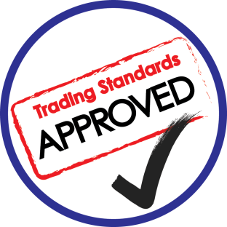
terminated by either party.

7 | Trading Standards’ Commitment
The Administrator will:

- Promote the Scheme to consumers.
- Maintain the Scheme’s website, ensure the accuracy of Member details, verify and moderate customer complaints and provide customer satisfaction feedback to members
- Provide a single point of contact though which general advice to members will be provided and through which more detailed legal advice can be obtained.
- Respond to all enquiries within 3 working days.
- Provide an Alternative Dispute Resolution Service to Members.
- Organise training for Members of the Scheme.
- Provide feedback and ‘a score’ following audit visits.

8 | Voluntary Termination
A Member may terminate Membership by giving 28 days notice to the Administrator.

9 | Suspension / Expulsion
Where complaints are received about a Member they will be fully investigated by the Administrator. Where there is evidence of sufficiently serious breaches of the law or the terms and conditions of the Scheme the Administrator may either suspend and/or terminate Membership of the Scheme.

The procedure and the appeal process is detailed in Appendix G

Where a Membership is terminated for such a reason no refund shall be made in respect of any Membership Fee paid.

10 | Fees and Terms of Payment
The following Fees are Payable

Initial Application Fee £263.72 + VAT
(This is a charge for conducting an initial assessment of (£316.46)
the eligibility of the applicant’s business and includes
time to access and obtain historical records of complaints
warnings and other infringements as well as the time
taken conducting the audit of the trader’s premises)

Annual Membership Fee £805.74 + VAT
(£966.89)

The Annual Membership Fee will be invoiced approximately 28 days prior to the renewal date.

All payments must be received within 28 days.

APPENDIX A

Trading Name(s) of Business Trading Address of Business
.............................................................................................................................................................................................
...............................................................
..........................................................................................................................................................

Limited Companies Sole Traders & Partnerships
Full Name(s) D.O.B.
................................................. ..../..../....
................................................. ..../..../....
................................................. ..../..../....
................................................. ..../..../....

Company Number .......................................
Company Name ........................................
Registered Office Address
......................................................................
...........................................................................

Tel No. Mobile No. FAX Number

Email Address of Applicant

Business Website Address

Nominated Person Complaints Contact
Please tell us who you nominate as the Please tell us who you nominate as the person to
point of contact for the Business in to contact in respect of consumer complaints if
respect to membership enquiries. this is different from the Business Contact

Name ________________________________
Position ________________________________
Tel No ________________________________
Email ________________________________
Name ________________________________
Position ________________________________
Tel No ________________________________
Email ________________________________

About the Business

How long has the business been trading?

How long from the present address?
If the business has been at its present address
Previous Name
Address

Date From .../.../... Date To .../.../...

for less than 6 months then please provide
details of previous addresses and trading names.

MOT Station Number

(If relevant)

Consumer Credit License No

(If relevant)

VAT Registration No

Declarations
Bankruptcy : Please provide details where the owner, partner(s) or director(s) have been declared bankrupt in the past 5 years.
Previous Convictions: Please tell us about any criminal convictions received by the Company, its directors, partners or owners within the past 6 years.

On behalf of the Business I confirm the information on this application is correct and I authorise the City of York Council to do the following:

- Check for intelligence and complaints about the Business, its owner, partners or directors held on any City of York database or file.
- Request searches of complaints or intelligence about the Business, its owners, partners or directors from any other enforcement body.

Name :..............................................  Position:...........................................  Signed:..............................................  Date: ..... / ..... / ..... | On receipt of this completed application form and payment of the £263.72 +VAT (£316.46) application fee you will be notified of the date of your audit.  Please make cheques payable to the City of York Council.  (Other payment details are available please ask)

Return this form together with your payment to:
Trading Standards
City of York Council
Hazel Court
YO10 3DS

APPENDIX B

B | Seeking Business
- General Requirement

All advertising by the Member must be :

- Legal
- Decent
- Honest
- Truthful

- Pricing

- All prices to consumers must be stated inclusive of VAT

- All additional charges (e.g. delivery or warranties) must made known to the consumer in writing before the consumer is obliged to contract and must be shown with equal prominence to any other pricing information.

- All ‘special offers’ or ‘deals’ must be available as advertised.

- All price reductions must clearly state the circumstances when any higher price has been or would be charged.

- Websites

- All websites must include the General Information required by Regulation 6 of The Electronic Commerce (EC Directive) Regulations 2002.

- All websites must comply with the Pre-contractual Information requirement of Regulation 13 of The Consumer Contracts (Information, Cancellation and Additional Charges) Regulations 2013

- All websites must comply with Consumer Information requirement of Regulation 19 of The Alternative Dispute Resolution for Consumer Disputes (Competent Authorities and Information) Regulations 2015

APPENDIX C

C | Communications Procedure
- General requirement

- All information must be provided to consumers in good time in order to allow them to make informed decisions as to whether to contract with the Business.

- All information with a consumer must be provided to them in a format which is easy for them to access having regard to any particular circumstances, needs or vulnerability the consumer may have.

- Documents

- Where the Member is a Sole Trader (that does not trade under the name of the owner) or a Partnership all business letters, written orders for goods or services, invoices and receipts; and written demands for payment must disclose the ownership details required by Regulation 1202 of The Companies Act 2006.

- Where the Member is a Registered Company all business letters, notices, bills of exchange, promissory notes, cheques, orders for goods or services, bills of parcel, invoices and demands for payment, receipts and letters of credit, licence applications, and all other business documents shall state the Registered Name of the Company in accordance with Regulation 6 of The Companies (Trading Disclosure) Regulations 2008.

- All written information about any goods, services, condition of vehicles or the need for any service or repair work must be given in a simple, clear and unambiguous manner before the service is provided or the contract concluded.

- No written contracts may contain terms and conditions included in Schedule 2 of the Consumer Rights Act 2015.

- Warranties and guarantees must be in simple language, clear and unambiguous and must be available for inspection to any consumer.

- Telephone Conversations

Where the Member seeks authority from a consumer by telephone to proceed with any work the Member must record the details of the call in writing. Wherever possible such authority will be confirmed by Email to the consumer

- Retention of Information

The Member must retain any written estimate, quotation, order, invoice and workshop job sheet for a period of 6 months following the date goods were supplied or a service was completed.

APPENDIX D

D | Sale of Vehicles
The Business will ensure that:

- All vehicles are inspected to ensure they are roadworthy and any necessary remedial work is completed before they are offered for supply; and in particular before being available to be test driven.

- Vehicles are only sold to consumers that are:

- Of satisfactory quality (relative to their age, mileage and price)
- Fit for their usual purpose and any particular purpose made known by the buyer
- As described
- The same as any Sample or Model shown to customer beforehand
- Reasonably Durable
- Safe

- The Member must carry out checks on mileage and accident history before offering for sale and inform the customer of any adverse history.

- The member must take all reasonable precautions to ensure that vehicles are described accurately, including but not exhaustively in regard to (indications of mileage, servicing, previous keeper numbers and identities; and accident history).

- Pre-registered vehicles are not described as ‘NEW’. They should be described as ‘Nearly New’, Pre-Registered or demonstrator as appropriate.

- Where vehicle mileage indications cannot be verified they must have a Vehicle Mileage Disclaimer placed in close proximity to the odometer reading.

- The disclaimer must be as ‘Bold. Precise and Compelling’ as the indication of mileage and must indicate that the mileage should be presumed to be inaccurate and should not be relied upon.

- A record is made of the precautions taken to ensure accuracy of descriptions and is retained for at least 12 months after the date of sale.

- The information about a vehicle’s history (excluding the purchase cost to the Member) is made available for inspection by a consumer.

- The Part-Exchange value of any vehicle accepted by the Member is clearly stated on purchase invoices and orders.

- Consumers are provided with the ‘On the Road’ price including all charges and taxes.

APPENDIX E

E | Servicing & Repair
The Member will ensure that:

- A written record is maintained of all diagnosis, the required parts and services to effect a repair and the cost including VAT.

- No work is undertaken without prior authorisation by the consumer and a record of authorisation is made and retained for the purposes of dispute and audit.

- Where diagnostic time and/or specialist equipment is required the consumer must be told the cost of such work per hour, the likely amount of diagnostic time required and the purpose of the work.

- The consumer agrees in writing to a maximum charge to be made for diagnostic time.

- Where additional work is required to be undertaken and the cost exceeds the amount initially agreed with the consumer, or exceeds any quotation by more than 10%, then further authorisation must be obtained from the consumer before such additional work is commenced.

- Unless otherwise agreed with the consumer, only new parts shall be used to repair vehicles.

- All parts removed from a consumer’s vehicle must be retained and offered to the consumer to inspect and retain if they wish unless you agree in writing to do otherwise. You may agree beforehand for instance that liquids such as used engine oil will be disposed of during servicing rather than being offered to the consumer.

- A written invoice for all serving and repair work is provided to the customer. The invoice must be dated and must itemise the work done as follows:

- The diagnosed fault or a statement such as 30,000 mile service.
- The results of any diagnostic work
- A description of any service carried out e.g. ‘wheel alignment’
- A description of each replacement part fitted
- The total cost inclusive of VAT
- Details of any guarantee or after sales service which applies which must include a statement that the consumer’s statutory rights are not affected.

APPENDIX F

F | Complaint Handling
A complaint is any expression of dissatisfaction brought to the attention of the business.

A major complaint is a complaint that continues after one attempt to resolve has been made.

The Member must ensure that;

- There is a person nominated within the Business to act as the Complaints Manager and oversee complaints.

- The Complaints Manager is authorised to take such action as may be necessary to resolve complaints on behalf of the Member business.

- Details of major complaints, including all correspondence with consumers is recorded and retained for at least 12 months from receipt.

- The major complaint records are available for inspection by the City of York Council on request.

- Major complaints are monitored and a review is conducted at least annually to determine any underlying causes or trends and avoid recurrence.

- All Complaints are responded to within 3 working days.

- Best efforts are made to find a satisfactory solution to complaints as soon as possible.

- Offers of repairs or replacement vehicles do not significantly inconvenience the consumer.

- Any refund to the consumer is made within 14 days of agreeing to do so.

- Where a complaint cannot be resolved :

- The consumer is given a ‘letter of deadlock’ informing him that the Member cannot settle the complaint with the consumer.

- The consumer must be informed that the Business is a Member of the Approved Garage Scheme which provides a non-judicial alternative dispute resolution procedure which the Member is obliged to use.

- The consumer should be given the contact details of the Scheme’s Administrator and be advised that they are able to access this Service without cost to themselves.

APPENDIX G

G | Disciplinary Procedure
- General

- The Administrator reserves the right to suspend or terminate the membership if the Member fails to meet the terms and conditions of the Scheme, or if the number of complaints and their severity are such that continued membership would bring the Scheme and into disrepute or harm the interest of consumers and other members .

- Disciplinary Process

- Where a breach of the Scheme’s Terms and Conditions is identified the Administrator will write to the Member describing the non-compliance and indicate the corrective action required to be taken by the Member and the time
- the decision making his response in writing to the Appellant within 21 days of within which this action must be taken.

- The Member will be warned that should the breach continue then the Membership may be revoked.

- Where a decision is made to revoke membership then this decision will be put into the public domain.

- Appeal Process

- Members and potential Members may appeal any decision made by the City of York Council to either refuse or revoke membership.

- Any appeal must be submitted within 21 days and must be in writing.

- All appeals must be made to the Head of Public Protection

- All Appeals will be acknowledged within 3 working days of receipt.

- The Head of Public Protection will investigate and review receipt.

- Where the Appeal relates to the conduct of any City of York employee then the matter may invoke the City of York Council’s complaints procedure. You will be informed of this in writing should this occur.

